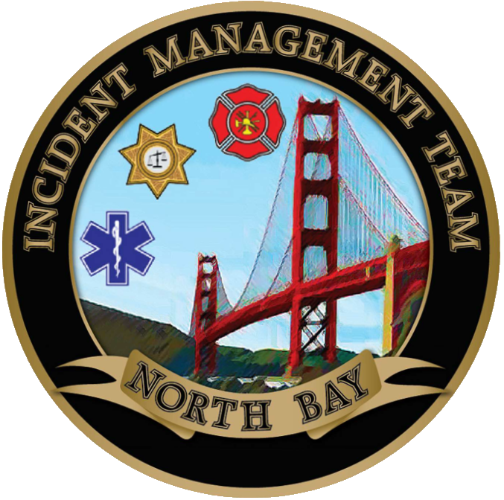

NORTH BAY INCIDENT MANAGEMENT TEAM

**PLANS**