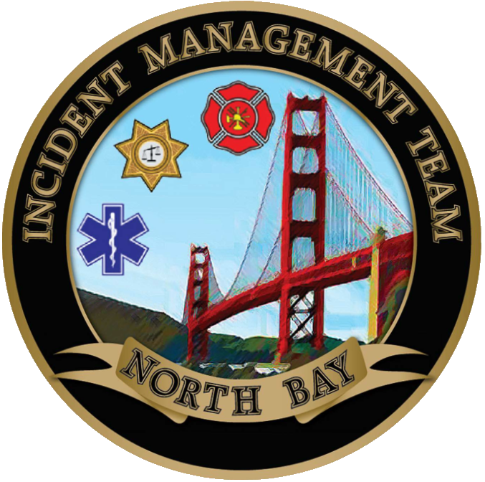

NORTH BAY INCIDENT MANAGEMENT TEAM

**A**