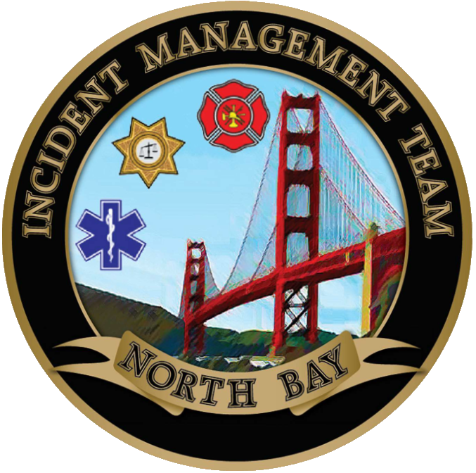

NORTH BAY INCIDENT MANAGEMENT TEAM

**­­­­­­A**