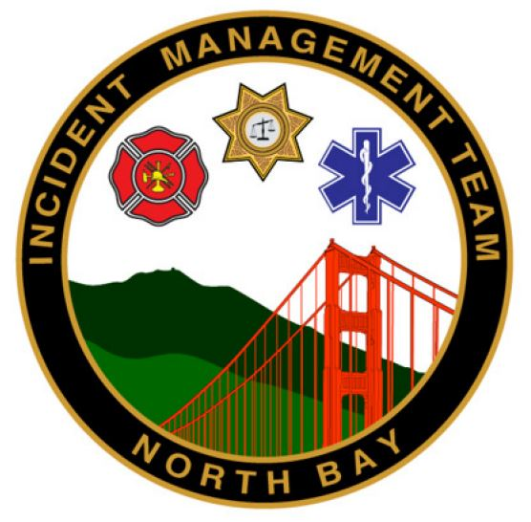

Create Lead in narrative here

✓ Task

- Create New IAP.

- Log into the North Bay Incident Management Team Google account.

- From a web browser and the web page http://www.nimsiap.org, access a “read only copy” of IAP.

- IAP will open in Google Sheets. Follow instructions to create copy.

- Prior to sharing this new sheet, DELETE the tab 100 READ ME.

- Additional information on accessing, creating and using the IAP in Google Sheets can be accessed through NBIMT Dropbox in the sub folder “Google Sheets.”

- When creating new IAP make sure to include QR code on cover page.

2. Check “Current Incident” folder in Dropbox.

- The most current IAP should be kept in this folder. Any previous IAP’s should be moved to the “Incident Documents” folder. This may require creating a new sub-folder with incident name and moving IAP’s and associated documents so that “Current Incident” folder is empty and ready for new incident.

- If new incident will cover multiple operational periods make sure to add sub-folder for each operational period.

3. Save PDF copy of finalized and approved IAP in current incident’s folder.

- Verify that IAP is correctly saved by testing QR code – does it take you to the current IAP or folder?

- Make sure all associated attachments such as operational maps, travel maps, etc., are saved in current folder and are also accessible through the QR Code.

- Do this BEFORE THE OPERATIONAL BRIEFING. Correct any problems with links prior to briefing.

4. When determining IAP duplication needs consider off-site need.

- Helibase, Air Attack Base, ECC, Expanded ECC.

- Determine if any of these can have QR Code emailed or texted to them so they access remotely.

- Arrange with Logistics for delivery of IAP’s to any off site areas.

- Determine off site mapping needs (briefing map(s), etc.)

5. Corrected IAP -

- Corrected copy marked with blue-inked pen.

- Update in Google Sheets. Mark cover page in red letters “CORRECTED IAP”.

- Save as new PDF with appropriate naming schedule and note as “CORRECTED IAP.”

7. Other.

