Fire Suppression Repair Plan
XXX Incident

CA-XXX-00000

Logo Here

Prepared by Name, Position
XXX Incident Fire Suppression Repair Plan

Outline

I. Objectives
II. Laws and Authority
III. Fire Suppression Repair Policy
A. Typical Fire Suppression Repair Activities
B. Unnecessary Activities
IV. General Repair Guidelines
A. Helispots/Drop Points/Staging Areas/Safety Zones
B. Roads
C. Firelines: Hand and Dozer
D. Concentrations of Slash
E. Watercourses
F. Archaeological or Historic Sites (if discovered) Appendix A. Fire Suppression Repair Statistics
Appendix B. Fire Suppression Repair Map

I. Objective:
The objective of suppression repair is to mitigate possible adverse effects to resources
resulting from fire suppression. Repair activities are focused on protection of water quality, erosion control, protection of cultural resources, stabilization of roads and dozer lines, fence repair and the maintenance of site productivity for all lands involved in the incident.

II. Laws and Authority:
Sections 4675 and 4676 of the Public Resources Code.

III. Fire Suppression Repair Policy:
Fire suppression repair is the repair of damage caused directly from fire suppression
activities. It is not the repair of infrastructure or rehabilitation of burned areas that happened as a result of the fire itself.

Damaged facilities will be repaired to their pre-fire condition. Projects too large or complex to be completed by the Fire Suppression Repair Group shall be transferred to the Comp/Claims Unit or the local Unit. Repair work shall only occur in locations authorized by the Operations Division and where fire suppression activities allow. Fire Suppression Repair Group resources shall evaluate all Divisions for appropriate repair needs. This includes areas inside and outside the fire perimeter, provided the damage was caused by official fire suppression activities. Unsanctioned fire suppression damage from operators outside the ICS are not repaired.

A. Typical Fire Suppression Repair Activities:
• Construction of waterbars to minimize erosion on roads and dozer lines where feasible and practical.

• Construction of waterbars on handlines where a threat to water quality exists and would be mitigated by drainage features.
• The use of road watering and grading equipment on unpaved roads used extensively during suppression activities in order to maintain or restore to prefire conditions.
• The restoration of drainage structures such as waterbars, rolling dips, culverts, and ditches to a prefire condition.
• Clearing of suppression-generated debris from watercourses to permit the free flow of water and prevent damage to aquatic habitat.
• The mulching, slashing and/or seeding of disturbed/exposed soil in excess of
800 sq. ft. on steep slopes found within the watercourse and lake protection zone of Class I and II watercourses.
• The closing of new roads, dozer lines or old roads that were opened during fire suppression activities.
• The repair of infrastructure that was damaged as a direct result of fireline construction during the course of fire suppression activities, such as fences, gates, and cattle crossings.
• The treatment or relocation of fire suppression-generated debris such as logs and slash.

B. Unnecessary Activities:
• Repair of fences, fence posts, utility poles, structures or other improvements damaged by the fire or backfiring activities.
• Repair of roads or drainage structures that were in poor condition or non- functioning prior to fire suppression activities.
• Resurfacing of roads.
• Waterbarring of roads or firelines that are unlikely to erode or contribute sediment to fish-bearing watercourses.
• Mulching or seeding disturbed/exposed soils that are unlikely to erode or contribute sediment to fish-bearing watercourses.

IV. General Repair Guidelines

A. Helispots/Drop Points/Staging Areas/Safety Zones

• Avoid leaving heavy accumulations of slash and/or debris; scatter so it appears natural, or breach windrows on rangelands so cattle livestock can access feed and water.
• Pull any berms back onto the site. Avoid expanding the exposed area. Install cross- drainage where indicated.
• Spread slash or brush over the area if available and land manager requests.
• Large exposed areas of soil may be ripped as an alternative to waterbarring. B. Roads

Roads shall be evaluated on an individual basis. Some sections require only the outside berm to be broken to allow drainage, while others may require waterbars. If rolling dips existed prior to the incident, they shall be restored as appropriate.

• Install waterbreaks where a waterbreak previously existed.
• Install or maintain rolling dips where they previously existed.
• Some cooperator roads that were reopened during the incident may require closing or blocking of access. These will be site-specific issues to be addressed as needed.
• Re-establish existing berms where applicable.
• Breach berms to avoid concentrating runoff where it might result in transport of sediment.
• Clean culverts plugged with soil and rock resulting from fire road use.
• Remove all slash and debris from culvert inlets/outlets that accumulated as a result of fire suppression efforts.
• Re-establish drainage such as crowned, out-sloped or in-sloped cross-section grades.
• Clean and grade ditch lines and lead-off ditches.
• Blading or grading of roads to restore/maintain stable road surfaces may be necessary.
Grading shall be done after containment and control objectives have been met or as
deemed appropriate by operations, branches or divisions.
• Vegetation displaced and deposited adjacent to roads shall be pulled and scattered to cover bare soil, or lopped in-place, or chipped, or rearranged to reduce hazards as necessary and feasible.

C. Firelines: Hand and Dozer

Repair Objectives – to reduce soil erosion and visual impacts.

• Install waterbars as described in the guidelines below. Waterbars are designed to intercept, slow, and spread precipitation runoff in order to reduce sediment transport and soil erosion. The objective is to move water off of the fireline before it can build energy to erode and transport sediment.

Waterbar Guidelines:
● Waterbars shall be spaced following the guidelines in the table below. Spacing
criteria is a general guide. Actual location of waterbars should be tailored to the topography and placement suited to the best dispersal of water flow.

Fireline slope Maximum Distance Apart
% (feet)
1-6 .................................... 300
7-9 .................................... 200
10-14 ................................ 150
15-20 .................................. 90
21-40 .................................. 50
41-60 .................................. 25

Recommended spacing for waterbars on firelines. Waterbars should be no further apart than this, but they may be closer. When in doubt, put in more.

● Location: Locate waterbars at natural slope breaks or to take advantage of natural features when possible. Direct water to unburned areas, and/or resistant surfaces with high vegetation cover when possible. Waterbars should extend beyond the width of the trail and discharge into undisturbed areas, rocky ground, or filter areas well protected with slash and vegetative cover.
● Depth and Width: Waterbars shall be cut into the ground surface; equipment
should not simply push up soil. On dozer constructed line, waterbar depths should be at least 6 inches; total height from bottom of ditch to top of waterbar should average at least 12 inches and not exceed 24 inches. On hand constructed line, waterbar depths should be at least 4 inches; total height from bottom of ditch to top of waterbar should average at least 8 inches and not exceed 18 inches. The width
of the waterbar channel should be enough to handle expected water flows and to
avoid plugging when a normal amount of sloughing occurs.

● Angle: In general, waterbars should be installed at an angle between 30 and 45 degrees. To determine the exact appropriate angle, determine the average gradient in percent slope of the fireline being repaired and add five percent to the average gradient. This approximates the angle in degrees for the water bar. Do not install water bars at an angle greater than 45 degrees, as this will increase water velocity rather than slow it down.

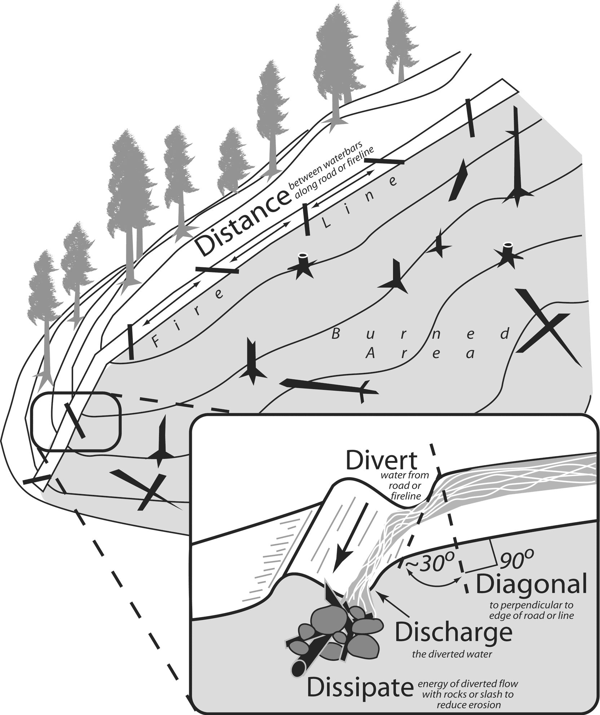

D. Concentrations of Slash

On areas that cannot be adequately waterbarred or as an optional alternative to waterbarring, slash may be spread to cover the soil to minimize erosion. Branches and logs should be placed along contour and be as thick as possible. This work should be completed only after the fire line in the area is contained with the concurrence of Branch, Operations, or the Incident Commander.

• Piles created by fire suppression operations within 150’ of permanent structures, public roads or private roads shall be lopped and scattered in pieces to create a layer no greater than 18” above the soil surface.
• Large concentrations of slash or debris (concentrations larger than 5ft x 5ft x 5ft) will be scattered or breached as appropriate for land uses.

The Five-D System for Effective Fireline Waterbars
To make effective waterbars on firelines, just remember the 5-D System. The five D’s are:
Distance, Diagonal, Divert, Discharge, and Dissipate.

Most forest values depend on healthy soils; clean water, streams full of fish, diverse wildlife habitats, productive timberlands, beautiful places, and so on. Firefighters strive to protect our soils by suppressing the wildfires that can damage them.

Methods used to fight fires, especially firelines, can cause erosion and soil degradation, and need to be treated to properly maintain forest values. Fireline surfaces usually cause runoff during heavy rainfall and snowmelt. Without waterbars, excessive runoff will concentrate and cause rills and gullies to form. Effective waterbars can prevent this from happening.

Distance: To be effective, waterbars must break up drainage areas and runoff on the fireline so that there’s not enough erosive energy available in runoff to erode the soil. To ensure that excess runoff cannot accumulate, waterbars must be placed the proper distance apart, based on the slope of the fireline. This breaks up the area that accumulates runoff, keeping it small enough to prevent damage. Erosion potential depends on slope and a table is provided on the next page that gives the maximum distance between waterbars, or between a waterbar and the next upslope drainage break.

Diagonal: After deciding where you will put each waterbar, the next decision is how to build them. An important principle in working with flowing water is: don't bully the flow, lead it. Waterbars built directly across a fireline oppose the water's energy and tend to fail. Waterbars built diagonal to the fireline lead
the water off and work much better. A diagonal waterbar has a gentle slope along its base that leads the water off. A simple rule is to add 5 to the slope of the road, in percent, and build the waterbar at that many degrees from perpendicular. Or simpler yet, just build them at 30 degrees off perpendicular (see the illustration on the next page).

Divert: A good waterbar will divert the water off the fireline. To do this the waterbar must be sufficiently deep to handle all the flow for as long as it's needed. Excavation is much more effective than fill in making a durable and effective waterbar (a ditch or a dip beats a dike).

Discharge: Another feature of a good waterbar is that it will discharge the flow. A good waterbar is not a dam – it must have an open outlet.

Dissipate: Finally, a good waterbar should dissipate the flow just below the outlet to exhaust its eroding power and cause it to filter into the soil. This may require placing slash, rock, or debris below the outlet, or fudging a bit on distance to take advantage of natural features that will dissipate the water's erosive energy.

So remember, when locating and building waterbars, place them the right distance apart, at a diagonal to the fireline, so that they divert, then discharge, then dissipate the energy of the flowing water. Be sure to make them deep enough so they'll be durable.

E. Watercourses

Remove soil from watercourses, swales or draws that resulted from fire suppression activities. Place waterbars on both sides of a watercourse where possible. Restore channel banks at fire line crossings to the bank shape above and below the crossing. Pull perched soil from drainage edges and feather it out onto fire trails.

• Remove debris created by fire suppression activities from stream channels. Do not remove large woody debris (LWD) that was in channels prior to the fire.
• Report major watercourse damage, if present, to the home unit resource manager.
• Where fire lines are constructed within 100’ of running watercourses, straw or wood chip mulching may be placed to prevent sediment from entering the watercourse. All loose
soil will be pulled away from the watercourse and stabilized.
• Block access to stream channels that were not previously accessible from roads and trails
(utilize slash and/or rock).

F. Archaeological or Historic Sites (if discovered)

• All potential sites shall be flagged and avoided.
• Impacted sites will be reported to the Fire Suppression Repair Group Supervisor as soon as possible.
• If sites are encroached upon, work will stop immediately and the Division/Group Supervisor or Fire Suppression Repair Group Supervisor will be notified, who will then notify a CAL FIRE Archaeologist.

G. Pumpkins/Water storage units used for suppression
Drain so as not to create erosion channels on roadways, meadows or into stream channels.

Archaeological and Historic Properties Fire-line Guidance

Do not compromise safety for the protection and preservation of archaeological and historic properties. When possible and prudent:

1.Be on the lookout for prehistoric and historic archaeological sites. These sites typically occur adjacent to streams and springs, confluences are often especially sensitive. However, sites can occur in other areas too. The most common indicators of prehistoric sites in this area are bedrock mortars, scatters of shiny black obsidian flakes from tool making activities, and dark midden soils. Historic era sites include homesteads that contain foundations, rock chimneys, and stone / brick lined wells. Historic-era mining sites are possible as well.

2. Note that much of the area has never been surveyed for archaeological resources and many sites out there have yet to be (re)discovered.

3. If you observe archaeological resources, flagged or unflagged, attempt to avoid with ground disturbing activities altogether.

4. If avoidance is not possible, minimize ground disturbance. Use a hand crew rather than a dozer to remove fuels from control lines that must cross a site, if possible.

5. Leave all artifacts in place as some may have been intentionally placed for religious or ceremonial reasons.

6. Note locations of discovered resources on a map, better yet, take site coordinates with a GPS. Leave information for the archaeologist so the sites can be relocated and protected during Fire Suppression Repair. Use SPECIAL TREATMENT ZONE flagging to indicate avoidance area, if available.

7. If you encounter a burial or other human remains, cease work in that area and contact the archaeologist and Sheriff/Coroner immediately.

Your help in preserving California’s non-renewable cultural resources is appreciated. Contact Information:
Name
Agency
Address
Phone
Email/other

Appendix A. Fire Suppression Repair Statistics

Incident Start Date:
Incident Start Time:
Incident Type:
Cause:
Incident Location:

Fences Damaged: (vary from wires cut, to dozed/8 panels) Gates Damaged:
Cattle Guards Damaged:
Culverts Damaged:
Airport Runways Damaged:
Primary Dozer Line (miles):
Alternate Dozer Line (miles):
Contingency Dozer Line (miles):
Emergency Dozer Line (miles):
Proposed Dozer Line (miles):
Dozer Line on Unpaved Road (miles):

Repair Resources
Dozers:
Excavator:
Graders:
Water Tenders:
Contractor Personnel:
Overhead:
Task Force:

Other:

Appendix B: Fire Suppression Repair Map (Source: SITL, other

