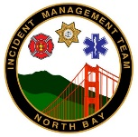
Command and General Staff Meeting
Participants: IC, UC, PIO, Safety, Liaison, Ops, Plans, Logs, Finance
Agenda Topic | Briefed By
Roll call and introduction of new participants and guests | PSC
Opening remarks | IC/UCG
Present incident objectives for the upcoming operational period | PSC
Describe/update current situation | SITL/OSC
Open discussion, including the following:  • Current status and issues  • Constraints, limitations, and shortfalls  • Input needed to finalize the incident objectives and strategies | OSC  Others
Establish precedence of incident objectives based on incident priorities | PSC
Outline of guidance to achieve objectives | IC/UCG
Open discussion (optional) | PSC
Closing remarks | UCG
Reminders; Meeting schedules, Document formats, etc… | PSC

