Quick Mapping for IMT
The purpose of this document is to identify how to put together quality map in a short period of time. This can be really helpful for an operations map for the first or second operational period (before we have real GIS), for a travel map or basecamp map.
This utilizes two free programs that are available to both Mac and PC users. You may also need an image editing/viewing program or an image capture or clipping application (almost anything will work).
SARTopo www.sartopo.com
The free version of SARTopo allows you to print 8.5” X 11” geo-referenced PDFs or 8.5” X 11” JPGs at 200 dpi. This doesn’t make for a great BAM for the ops briefing. However, you can print to a plotter using Adobe. You will lose quality but, it should still be readable.
Adobe Acrobat Reader DC - Comes free with both Windows and MAC OS systems.
The maps and the process can be improved by having a subscription to SARTopo and having either an upgraded version of Acrobat or another PDF editing program.
Process for using free versions of both
- Open SARTopo. If you have a subscription, log in now.

- Search for the area of your desired map. Enter the place name or coordinates and hit “enter”:
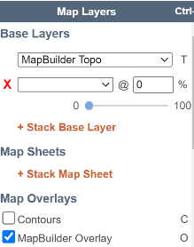
- Select the best Preset layers for your map (Usually it is going to be “MapBuilder Topo” with the “MapBuilder Overlay”). Bear in mind that your printed map will likely have more detail than what you see on screen. You can also mix layers to your own liking. However, I won’t go into that now. You can also add additional layers to the map. There are multiple layers available including contours, Slope angle shading, weather stations, fire history, geology, structures, and many more. If you add layers, you can set their transparency to blend layers

- Zoom to a scale where you can see all of the area that you want to include on your map.

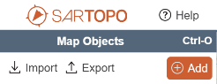
- Enter your perimeter. Enter your perimeter in a clockwise fashion. Click on “Add” in the Map Objects panel and select “Line”. You can also right click anywhere on the map and select “Line”.
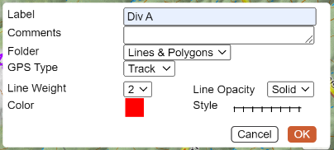
Give your line a name such as DIV A. Leave comments blank, unless you want to put in the date and time or something similar. Leave Folder, GPS Type, and Line Opacity as their default. Start Line Weight as 2. You can change it later if needed. Select your color (red/black) and then select a line style (Open line/contained line).
Start drawing your line by clicking the starting point on the mapClick each point along the track. To end the line, either double click at the end point or click on OK. If you have to enter both open and contained line on a single division, you can create two separate lines. If one is a smaller section, you may choose to not label it. All labels will show up on the map.
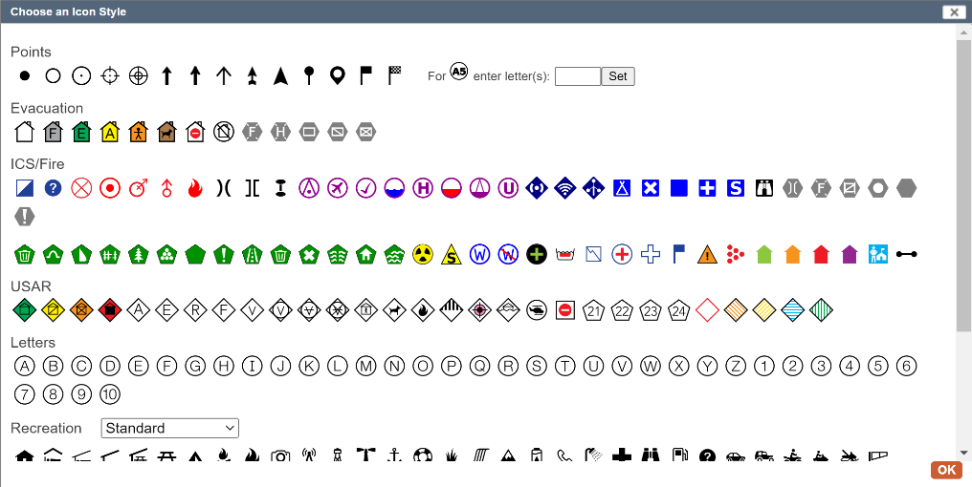
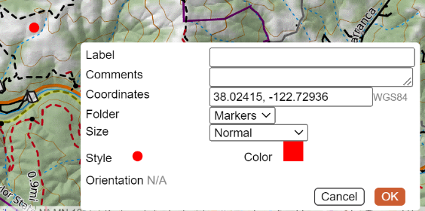
- Add Markers to the map. Markers can be any point such as division breaks, drop points, ICP, staging areas, etc. Click on “Add Object” and select “Marker”. You can also right click anywhere on the map and select “Marker”. As soon as you select Marker, a marker will appear on the map. If you selected Marker from the Add button the marker will be in the center of the map. If you right-clicked, it will appear where you right clicked. If you want to move it, you can click on it a drag it to your desired location. As you move a marker, the coordinates in the Coordinates field will be updated. You can also enter coordinates directly into the field and the marker will be place accordingly.
The marker that shows up will be the last marker that you used. You can select the marker style by clicking on the marker in the opened dialog (Style).
The Choose an Icon Style window (Right) will open to allow you to pick the marker style. You may also add icons that are available on the internet. You have to enter their url in the field at the bottom of the window.
If you add a label, the label will show up on the map. For some markers you may not want a label (divison or branch breaks). You may leave the label blank. However, you may want to add a comment. This is helpful if you print a coordinate list (all markers).
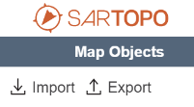
- Importing data. You can import data directly from KML, KMZ, GPX, and GeoJSON files. Files must be available to your local computer (hard drive, USB, Drop Box, Google Drive, etc). Click on Import in the upper left corner. Select your file and open it. Most formats will allow you to select specific tracks or objects in the file to import. Once imported, you can edit to change to the style, color, icon, etc. You can also trace with a new line and delete the imported data.

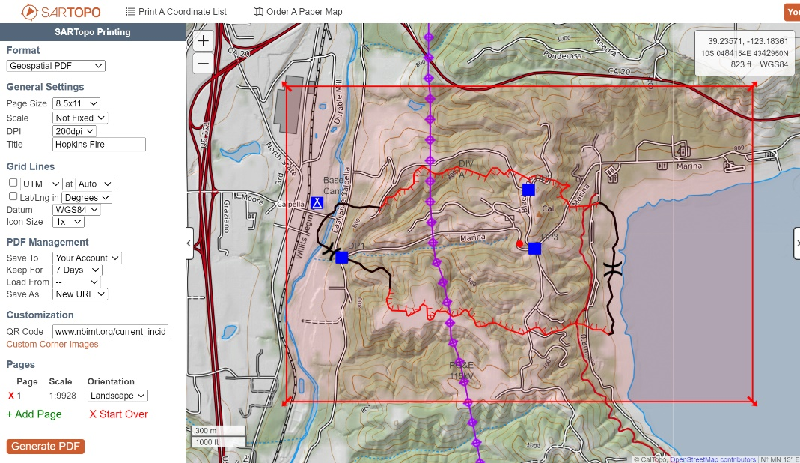
- Printing to Geo-referenced PDF. Click on the printer icon on the left side of the map. This opens new browser window.
* Set your format to Geospatial
PDF.
* Page size is maximum of
8.5x11, unless you have a paid
account.
* Leave scale as Not fixed.
* Max DPI is 200, unless you
have a paid account.
* Enter the title of your
incident.
* Skip grid lines, leave datum at
WGS84.
* Set icon size to 1 or 2. You can
test which looks better.
* Leave all PDF management settings as default.
* Customization is only available in the paid version.
QR Code allows you to enter a url and have a QR code generated on the map.
By default SARTopo will place a QR to the map itself.
Custom Corner Images allows you to place legends, logos, titles or other inserts into the map.
These can be any JPG or PNG accessible to your local computer.
* Select either landscape or portrait orientation.
* Drag the corners of your red rectangle to include your printable area. Click on the red dot in the center to drag
the entire rectangle. Make sure to leave extra area for legends and titles.
Click on Generate PDF to create your map.

