

NAME

STREET ADDRESS

CITY, STATE ZIP

site INFORMATION

**general SITE INFORMATION**

|  |  |
| --- | --- |
| Date information obtained |  |
| Site Name |  |
| Street Address |  |
| City |  |
| Zip Code |  |

|  |  |  |
| --- | --- | --- |
| Site Owner or Manager |  |  |
| Site Owner or Manager's Address (Address, City, State Zip Code) |  |  |
| Site Owner or Manager's Phone Number |  |  |

|  |  |  |
| --- | --- | --- |
| City/County Jurisdiction |  |  |
| Police Jurisdiction & Division/Region |  |  |
| Fire Department Jurisdiction & Division/Region |  |  |
| County Supervisory District |  |  |
| City Council District |  |  |

|  |  |  |
| --- | --- | --- |
| Thomas Guide Page and Grid |  |  |
| Latitude |  |  |
| Longitude |  |  |

|  |
| --- |
| ADDITIONAL INFORMATION |

**SITE DETAILS**

*The following information pertains to the space on site specifically designated for use as a Commodity Points of Distribution (C-POD) in the pre-planned C-POD IAP.*

|  |  |
| --- | --- |
| Dimensions of site in feet |  |
| Size of site in acres |  |

C-POD SITE INFORMATION

|  |  |
| --- | --- |
| Paved, concrete, or gravel hard-stand |  |
| Maximum load site can withstand |  |
| Accessible at all times |  |
| Access controlled by an automated gate |  |
| Location of driveway(s) |  |
| Spike strips at any of the driveways |  |
| Additional Space Used |  |

SITE SAFETY

|  |  |
| --- | --- |
| Perimeter Fencing |  |
| Fixed lighting through the site |  |
| Exterior lighting |  |
| Site monitored by the use of closed-circuit TV cameras |  |
| Is there a public address system |  |

|  |  |
| --- | --- |
| Covered areas |  |
| Fixed equipment or non-fixed heavy equipment located on the site that may be difficult to move |  |

SITE ACCESSIBILITY

|  |  |  |  |  |
| --- | --- | --- | --- | --- |
| Sidewalks leading to the site have wheelchair access |  |  |  |  |
| Uneven surfaces leading up to the site |  |  |  |  |
| Is there a ramp from the staff parking location leading up to the POD location? If so, note location and change of elevation. |  |  |  |  |

## GENERAL TRANSPORTATION DETAILS

## Freeway, Highway, or Toll Road Access

|  |  |  |
| --- | --- | --- |
| Freeway/Highway/Toll Road | Nearest On-Ramp location | Nearest Exit |
|  |  |  |  |  |

## Major Cross Streets

|  |  |
| --- | --- |
| Street Name | Direction Street Runs |
|  |  |
|  |  |

## Streets Bordering the SITE

|  |  |  |  |
| --- | --- | --- | --- |
|  | Street | Is it a one-way? | Are there median barriers?  If so, note location of turn pockets. |
| North side |  |  |  |
| South side |  |  |  |
| East side |  |  |  |
| West side |  |  |  |

TRAFFIC CONSIDERATIONS

|  |  |
| --- | --- |
| Major Intersections within 1 Mile of Site |  |
| Things that May Impact Traffic |  |
| Accessibility Considerations |  |
|  | |

## Public Transit Accessible within ¼ Mile of the SITE

|  |  |  |  |  |
| --- | --- | --- | --- | --- |
|  | Provider | Line Number | Direction | Stop Location |
| Bus |  |  |  |  |
| Light Rail |  |  |  |  |
| Subway |  |  |  |  |

|  |
| --- |
| ADDITIONAL INFORMATION |

# TIGHT VIEW VICINITY MAP OF SITE

# TIGHT VIEW AERIAL IMAGE OF SITE

# WIDE VIEW VICINITY MAP OF SITE

# WIDE VIEW AERIAL IMAGE OF SITE

NAME OF SITE

ADDRESS

CITY, CA ZIP

commodity

Point of distribution (C-POD)

Incident Action PLAN

Incident Name & Date(s)

Incident Commander Signature

Incident Commander Signature

Incident Commander Signature

**ICS FORMS & ATTACHMENTS CHART**

Basic Planning Assumptions

ICS FORMS

ICS 202 – Incident Objectives

ICS 203 – Organization Assignment List

ICS 204 – Traffic Management Group

ICS 204 – Security Group

ICS 204 – Loading Group

ICS 205 – Communications Plan

ICS 205T – Communications Plan (Telephone)

ICS 206 – Medical Plan

ICS 213 – General Message

ICS 214 – Activity Log

ICS 230 – Meeting Schedule

ATTACHMENTS

Attachment A: C-POD Details, Client Flow & Equipment Needed

Attachment B: Lane 1 Details: Supply, Loading & Vehicle Lines

Attachment C: Mass Transit-Pedestrian Line: Supply & Loading Lines

Attachment D: Staff Transportation & Parking Details

Attachment E: Diagram of Site

Attachment F: Close Up Diagram of Supply Line, Loading Line & Vehicle Line

Attachment G: Close-Up Diagram of Pedestrian Line

**BASIC PLANNING ASSUMPTIONS**

**EDIT THIS INFORMATION BASED ON ACTUAL SITE**

* This site will be utilized as a Type III C-POD, which can serve about 5,000 people a day (assuming that on average one vehicle represents three people). This equates to approximately 140 cars per hour. A Type III C-POD must be at least 150 feet by 300 feet.
* A Type III POD has three loading points and only one vehicle lane.
* This C-POD can accommodate a pedestrian lane, including three loading points, for clients transported to the site via designated C-POD buses.
* Pallets storing commodities will be 4’x4’.
* Delivery of commodities will occur after C-POD operational hours. Each operational period will be 12 hours long.
* C-POD site has a Traffic Index (TI) of 5 or higher, which can withstand heavy loads during a C-POD operation.
* People who walk-up to the C-POD cannot be served at this location due to safety concerns. This site can only serve clients who arrive in a vehicle and/or on the designated bus.
* Unlike the Vehicle Lane, the Mass Transit/Pedestrian Lane will not have separate loading and supply lines; the commodities distribution to pedestrians will come directly from the supply pallets.
* Traffic control cones should be spaced 10’ feet apart at the pedestrian lane and 20’ feet apart along vehicle routes and at the vehicle lane.

|  |  |  |
| --- | --- | --- |
| ICS 202INCIDENT OBJECTIVES | **EVENT NAME/LOCATION** | **OPERATIONAL PERIOD** |
| **Control OBJECTIVES** | | |
| **WEATHER FORECAST FOR OPERATIONAL PERIOD** | | |
| **GENERAL / SAFETY MESSAGE** | | |
| **Other information** | | |
| **PREPARED BY** | | **DATE/TIME** |

|  |  |  |
| --- | --- | --- |
| ICS 203ORGANIZATION ASSIGNMENT LIST | **EVENT NAME/LOCATION** | **OPERATIONAL PERIOD** |

|  |  |  |
| --- | --- | --- |
| ICS 204ASSIGNMENT LISTTRAFFIC MANAGEMENT group | **EVENT NAME/LOCATION**  **NAME C-POD** | **OPERATIONAL PERIOD** |

|  |
| --- |
| **OVERALL STRATEGIES** |
| * Traffic patterns will be designed to take as many client vehicles off the street and into the C-POD site as possible. * Clients will arrive in personal vehicle or C-POD bus. Clients who walk-up to the C-POD will not be granted access. * Traffic controllers will direct client vehicles and designated C-POD buses to the C-POD in a controlled fashion. * Traffic controllers will direct client vehicles and designated C-POD buses through the C-POD in accordance with the plan.   **EDIT ALL INFORMATION ON THIS PAGE BASED ON ACTUAL SITE** |

|  |  |  |  |  |  |  |  |  |  |
| --- | --- | --- | --- | --- | --- | --- | --- | --- | --- |
| **name** | | | **traffic management**  **Post Location** | | **Description of Functions and Duties** | | | | |
|  | | |  | | * Direct client vehicles to travel west on L Street. * Communicate with other traffic posts to ensure orderly traffic flow. | | | | |
|  | | |  | | * Allow access to C-POD designated buses and direct buses to pedestrian lane at north end of the lot. * Client vehicles shall be directed to the L Street West Driveway. * Do not allow walk-up entry. | | | | |
|  | | |  | | * Direct client vehicles to the parking lot through the L Street Driveway. * Do not grant access to people who walk-up to the site. | | | | |
|  | | |  | | * Direct client vehicles to the far west and north around the parking lot before turning east to travel towards the C-POD. | | | | |
|  | | |  | | * Direct mass transit buses to pedestrian lane. * Stop vehicular traffic to allow buses to access pedestrian lane. | | | | |
|  | | |  | | * Halt vehicular traffic to allow mass transit buses to drive east towards the Figueroa Place Driveway and egress. | | | | |
|  | | |  | | * Direct client vehicles to access the vehicle loading line. * Allow 3 vehicles per cycle, one vehicle per loading point. * Communicate and coordinate with traffic management post East of Vehicle Loading Line. | | | | |
|  | | |  | | * Direct client vehicles to access the vehicle loading line. * Allow 3 vehicles per cycle, one vehicle per loading point. Direct client vehicles to stop when the forward car has reached the easternmost loading point. Direct client vehicles to egress through Figueroa Place Driveway when loading is complete. * Communicate and coordinate with traffic management post West of Vehicle Loading Line. | | | | |
|  | | |  | | * Assist with traffic control on Figueroa Place as Mass Transit buses and client vehicles exit C-POD through Figueroa Place Driveway. | | | | |
|  | | |  | |  | | | | |
| **Signature of TRAFFIC MANAGEMENT GROUP SUPERVISOR** | | | | | **Signature oF OPERATIONS SECTION CHIEF** | | | | |
| ICS 204ASSIGNMENT LISTSECURITY GROUP | | | **EVENT NAME/LOCATION**  **NAME C-POD** | | | **OPERATIONAL PERIOD** | |
| |  | | --- | | **Security MEASURES AND Strategies** | | * Security personnel will be positioned throughout the C-POD and should regularly patrol the location to deter crime and promote the security of clients, C-POD staff, and commodities. * Marked law enforcement vehicles should be deployed in strategic locations (C-POD L Street East and West Driveways and Figueroa Place Driveway) so as to provide an immediate visual deterrent for any potential disruptions. * A plan should be developed by the Security Group to verify staff credentials before granting access to restricted areas, e.g. staff rest tent and restrooms, any building on the premises, staff parking areas. * Clients will arrive in personal vehicles or C-POD bus. Clients who walk-up to the C-POD will not be granted access.   **This serves as an example. Update with INFORMATION BASED ON ACTUAL SITE.** | | | | | | | | |
|  | | | | | | | |
| **name** | **Security Post Location** | | | | **Function(s)** | **Number of Armed Officers** | **Number of Unarmed Officers** |
|  |  | | | | * Monitor vehicles as they enter the C-POD site and prohibit unauthorized entry. |  |  |
|  |  | | | | * Prohibit client vehicles and any clients who walk up to the site from entering. * Only allow buses to enter. |  |  |
|  |  | | | | * Monitor clients as they progress through the pedestrian loading lines. |  |  |
|  |  | | | | * Monitor vehicles as they enter the vehicle loading lines. * Prohibit clients from exiting their vehicles and maintain order. |  |  |
|  |  | | | | * Prohibit unauthorized entry through the Figueroa Place Driveway. * Monitor vehicles as they exit the Vehicle Loading Line. * Coordinate the orderly flow of vehicles leaving the C-POD with the assigned traffic officer. |  |  |
|  |  | | | | * Regularly patrol the C-POD site to monitor and assist, as needed. * Provide scheduled relief to fixed post personnel. |  |  |
| **Total Officers:** | | | | | |  |  |

|  |  |
| --- | --- |
| **Signature of SECURITY GROUP Supervisor** | **Signature of OPERATIONS SECTION CHIEF** |

|  |  |  |
| --- | --- | --- |
| ICS 204ASSIGNMENT LISTLOADING group | **EVENT NAME/LOCATION**  **NAME OF SITE C-POD** | **OPERATIONAL PERIOD** |

|  |
| --- |
| **OVERALL STRATEGIES** |
| * Loading Teams will be utilized for each vehicle loading point (total of 3), and each pedestrian loading point (total of 3). Each loading point has a team of 3 members. * Cars will pull up to the vehicle loading lines 3 at a time; one for each loading point. * Clients will not get out of their cars; clients will pop their trunk for commodities loading to minimize the number of people getting in and out of their cars, to save time, and to ensure the safety of clients and C-POD staff. * The Mass Transit/Pedestrian Lane will not have separate pallets for loading and supply lines; the commodities distribution to pedestrians will come directly from the supply pallets.   **This serves as an example. Update with INFORMATION BASED ON ACTUAL SITE.** |

| **name** | **loading Post Location** | **Description of Functions and Duties** | **Number of Loading staff** |
| --- | --- | --- | --- |
|  | Vehicle Loading Point | * Load supplies into client vehicles, and coordinate resupply of loading line. * Direct clients to remain in their cars and to pop their trunk for commodities loading. * Communicate and coordinate with traffic management posts west and east of vehicle loading line. |  |
|  | Pedestrian Line Loading Point | * Distribute commodities to pedestrian line clients, and coordinate resupply of loading line. * Direct clients to Mass Transit pick up point at the southeast corner of the Pedestrian Lane. |  |
|  |  |  |  |
|  |  |  |  |
|  |  |  |  |
|  |  |  |  |
| **Total Officers:** | | |  |

|  |  |  |  |
| --- | --- | --- | --- |
| **Signature of lOADING GROUP SUPERVISOR** | | **Signature oF OPERATIONS SECTION CHIEF** | |
| ICS 205COMMUNICATIONS PLAN (RADIO) | | **EVENT NAME/LOCATION** | | **OPERATIONAL PERIOD** | |

|  |  |  |  |  |  |
| --- | --- | --- | --- | --- | --- |
| **System/Cache** | **Channel** | **Function** | **Frequency/Tone** | **Assignment** | **Remarks** |
|  |  |  |  |  |  |
|  |  |  |  |  |  |
|  |  |  |  |  |  |
|  |  |  |  |  |  |
|  |  |  |  |  |  |
|  |  |  |  |  |  |
|  |  |  |  |  |  |
|  |  |  |  |  |  |
|  |  |  |  |  |  |
|  |  |  |  |  |  |
| **PREPARED BY** | | | | **DATE/TIME** | |

|  |  |  |
| --- | --- | --- |
| ICS 205TCommunications plan (Telephone) | **EVENT NAME/LOCATION** | **OPERATIONAL PERIOD** |

|  |  |  |  |  |
| --- | --- | --- | --- | --- |
| **Name** | **Position or Responsibility** | **Phone #** | | **Notes** |
| CITY POD DESK | Provide City assistance and support to Incident Commanders and Volunteer Coordinators. |  | |  |
|  |  |  | |  |
|  |  |  | |  |
|  |  |  | |  |
|  |  |  | |  |
|  |  |  | |  |
|  |  |  | |  |
|  |  |  | |  |
|  |  |  | |  |
|  |  |  | |  |
|  |  |  | |  |
|  |  |  | |  |
|  |  |  | |  |
| **PREPARED BY** | | | **DATE/TIME** | |

|  |  |  |
| --- | --- | --- |
| ICS 206Medical Plan | **Event Name/Location** | **Operational Period** |

|  |  |
| --- | --- |
| **PILL POD** | **VACCINE POD** |

|  |  |  |  |  |  |  |  |  |
| --- | --- | --- | --- | --- | --- | --- | --- | --- |
| **Ambulance Services** | | | | | | | | |
| *Ambulance service will be provided by the Los Angeles Fire Department through the 9-1-1 system.* | | | | | | | | |
| **Hospitals** | | | | | | | | |
| **Name** | | **Address** | | | **Phone** | | **Helipad (Y/N)** | **Burn Center (Y/N)** |
|  | |  | | |  | |  |  |
|  | |  | | |  | |  |  |
|  | |  | | |  | |  |  |
| **Medical Emergency Procedures** | | | | | | | | |
| * If a staff person suffers a **medical emergency**, care shall be rendered (if possible) and 9-1-1 **shall** be called. The Public Health Clinical Staff may render care, but may not assume patient care responsibility. * After 9-1-1 is called and an ambulance is dispatched, send a runner to the street to direct the ambulance crew to the patient. * Staff should follow their internal workers compensation guidelines for on-the-job related illness or injuries. * Notify organizational representative of illness or injuries to their respective volunteers. * Transport of a staff person to a hospital will be according to Los Angeles County Emergency Medical Services Protocol. * **If staff person refuses medical care and/or transport to the hospital**, the refusal **shall** be documented on the Activity Log (ICS 214). The greatest source of liability for health care providers is a patient who refuses care with being explained to possible adverse consequences of that refusal. | | | | | | | | |
| **Signature of Medical Unit Leader** | | | | **Signature of Safety Officer** | | | | |
| ICS 213GENERAL MESSAGEDEMOBILIZATION PLANNING | | **EVENT NAME/LOCATION** | | | **OPERATIONAL PERIOD** | | | |
| |  |  |  | | --- | --- | --- | | **To:** | **Position:** | | | **From:** | **Position:** | | | **Subject:**  **Demobilization Planning** | **Date:** | **Time:** | | **Message** | | | | **Consider the following when planning for demobilization:**   * The number of clients in line, the amount of commodities left, and the through-put per hour. * If the amount of available commodities is projected to run out before the POD closing, a traffic management post must be placed at the end of the line to advise clients that only those in line are guaranteed commodities. * If the line is going to be closed due to commodities running out before POD closing, place a traffic management post near the ingress driveway and closest intersection with information on other/future POD locations. * Consider releasing volunteers first. * Consider releasing entire units/groups at the same time. | | | | **Signature:** | **Position:** | | | **Reply** | | | |  | | | | **Date:** | **Time:** | **Signature/Position:** | | | | | | | | | |

|  |  |  |
| --- | --- | --- |
| ICS 214ACTIVITY LOG | **EVENT NAME/LOCATION** | **OPERATIONAL PERIOD** |

|  |  |  |  |
| --- | --- | --- | --- |
| **NAME** | **AGENCY** | **POSITION** | |
| **TIME** | **SIGNIFICANT EVENTS** | | |
|  |  | | |
|  |  | | |
|  |  | | |
|  |  | | |
|  |  | | |
|  |  | | |
|  |  | | |
|  |  | | |
|  |  | | |
|  |  | | |
|  |  | | |
| **GENERAL COMMENTS** | | | |
|  | | | |
|  | | | |
|  | | | |
| **SIGNATURE** | | | **DATE/TIME** |

|  |  |  |
| --- | --- | --- |
| ICS 230DAILY MEETING SCHEDULE | **EVENT NAME/LOCATION** | **OPERATIONAL PERIOD** |

|  |  |  |  |  |
| --- | --- | --- | --- | --- |
| **Date/Time** | **Meeting** | **Purpose** | **Attendees** | **Location** |
| *Start of shift* | General Briefing | Incident Commander(s) gives general C-POD operational information to workers | All C-POD Staff |  |
| *Start of shift* | Community Profile Briefing | Incident Commander(s) inform C-POD workers about the community being served | All C-POD Staff |  |
| *Start of shift* | Safety Briefing | Safety Officer informs C-POD workers about safety risks and procedures | All C-POD Staff |  |
| *Start of shift* | Just-In-Time Training | Section Chiefs and Group/Branch Supervisors provide training to C-POD workers on their specific job assignment | All C-POD Staff |  |
|  | Situational Meeting | Evaluate inventory; determine whether additional commodities can/should be ordered | Incident Commanders, Planning Chief, Operations Chief, Documentation Unit Leader, Supply Unit Leader |  |
|  |  |  |  |  |
|  |  |  |  |  |
|  |  |  |  |  |
|  |  |  |  |  |
|  |  |  |  |  |
|  |  |  |  |  |
|  | Closing Planning Meeting | Plan for the demobilization of the POD | Incident Commanders, Section Chiefs |  |
|  |  |  |  |  |
|  |  |  |  |  |
| PREPARED BY | | | DATE/TIME | | |

**Attachment A: C-POD details, CLIENT FLOW & equipment needed**

|  |  |
| --- | --- |
| **EVENT NAME/LOCATION** | **OPERATIONAL PERIOD** |

SITE CAPACITY

|  |  |
| --- | --- |
| Type I, II, or III Site  Type I = 4 Vehicle Lanes*  Type II = 2 Vehicle Lanes*  Type III = 1 Vehicle Lane*  *Lane = Supply Line, Loading Line & Vehicle Line |  |
| Total Number of Mass Transit-Pedestrian Lanes  (Lane = Supply Line, Loading Line & Pedestrian Line) |  |
| Accessibility Considerations |  |

LOCATION OF DIRECTIONAL SIGNAGE

|  |  |
| --- | --- |
| Commodity Distribution Ahead |  |
| Enter |  |
| Loading Point |  |
| Exit – Do Not Enter |  |
| One Way |  |
| Turn Here |  |
| Commodities Provided By __________ |  |
| Site Staffed By__________________ |  |

GENERAL INGRESS/EGRESS INFORMATION

|  |  |
| --- | --- |
| Location of Driveways Used In this Plan |  |
| Accessibility Considerations | Ingress:  Egress: |

C-POD Client Flow

|  |
| --- |
| Description of C-POD Flow |
| **This serves as an example. Update with INFORMATION BASED ON ACTUAL SITE.**   * Clients will enter the site through the L Street West Driveway (approximately 1,000 feet west of the L Street / Figueroa Place intersection). Clients will be directed to loop around the western side of the parking lot, traveling to the far northwest of the site before turning east towards the vehicle lane. * Clients in the C-POD site will be directed by traffic management personnel and traffic control devices (e.g. cones) towards the vehicle lane, where commodities will be distributed. * Clients will be directed through the loading points in a controlled fashion: three vehicles at a time will drive through the loading line (the first car should drive to the east most loading point). Once all 3 of the vehicles receive their commodities, they will be directed to exit the C-POD and the next three cars will enter the loading line. * Clients will egress through the east driveway onto Figueroa Place, where they can turn either north or south to access major arteries. * Mass transit vehicles will be directed by traffic management personnel through the L Street East Driveway, and directed northeast to the pedestrian lane. * Pedestrians will be dropped off at the northwest corner of the pedestrian lane, travel south to pick up their commodities at one of three loading points, and be picked up by mass transit at the southeast corner of the pedestrian lane. * Mass transit will egress by traveling east in a designated mass transit traffic lane through the parking lot to the Figueroa Place Driveway. |
| Accessibility Considerations |
| **This serves as an example. Update with INFORMATION BASED ON ACTUAL SITE.**   * There is a guard shack located in the center of the L Street East Driveway. * There is a spike strip at the Figueroa Place driveway. |

TOTAL NON-PERSONNEL EQUIPMENT NEEDED TO SUPPORT THIS PLAN

|  |  |  |  |  |  |  |  |  |
| --- | --- | --- | --- | --- | --- | --- | --- | --- |
|  | Commodity Distribution | | | | | Staff | | **TOTAL** |
|  | Per Supply Line | Per Loading Line | Per Vehicle Line | Per Pedestrian Line | Mass Transit Area | Staff Parking Area | Staff Drop-Off/ Pick-Up Area |
| Cones |  |  |  |  |  |  |  |  |
| Barricades |  |  |  |  |  |  |  |  |
| Temporary Restrooms |  |  |  |  |  |  |  |  |
| Portable Lights |  |  |  |  |  |  |  |  |

TOTAL PERSONNEL EQUIPMENT NEEDED TO SUPPORT THIS PLAN

|  |  |  |
| --- | --- | --- |
| Equipment | personnel Needed | Amount |
| Forklift |  |  |
| Pallet Jack |  |  |

|  |  |
| --- | --- |
| PREPARED BY | DATE/TIME |

**Attachment B: LANE 1 details: SUPPLY, LOADING & VEHICLE LINES**

|  |  |
| --- | --- |
| **EVENT NAME/LOCATION** | **OPERATIONAL PERIOD** |

**if you are creating an iap for a type ii or iii c-pod, either a) duplicate this page for each lane or B) change the heading for each table to be all inclusive.**

SUPPLY LINE 1: SUPPLY TRUCKS

|  |  |
| --- | --- |
| Dimensions of Designated Area |  |
| Location for Supply Unloading |  |
| Specific Driveway(s) Designated for Ingress |  |
| Special Instructions for Ingress |  |
| Specific Driveway(s) Designated for Egress |  |
| Special Instructions for Egress |  |
| Accessibility Considerations |  |

SUPPLY LINE 1: Supply pallets

|  |  |
| --- | --- |
| Dimensions of Designated Area |  |
| Location for Supply Pallets |  |
| Space between Supply Line and Loading Line |  |

supply line 1: staff care facilities

|  |  |
| --- | --- |
| Location of Staff Temporary Rest Tent |  |
| Location of Staff Temporary Restrooms |  |
| Accessibility Considerations |  |

LOADING LINE 1

|  |  |
| --- | --- |
| Dimensions of Designated Area |  |
| Specific Location of Loading Line |  |
| Space Allocated for Each Loading Point |  |
| Space Between Each of 3 Loading Points |  |

VEHICLE LINE 1

|  |  |
| --- | --- |
| Dimensions of Designated Area |  |
| Specific Driveway(s) Designated for Vehicle Ingress |  |
| Specific Driveway(s) Designated for Vehicle Egress |  |

|  |  |
| --- | --- |
| PREPARED BY | DATE/TIME |

**Attachment C: MASS TRANSIT-PEDESTRIAN LINE: SUPPLY & LOADING LINES**

|  |  |
| --- | --- |
| **EVENT NAME/LOCATION** | **OPERATIONAL PERIOD** |

PEDESTRIAN SUPPLY LINE: SUPPLY TRUCKS

|  |  |
| --- | --- |
| Dimensions of Designated Area |  |
| Location of Designated Area |  |
| Specific Driveway(s) Designated for Ingress |  |
| Special Instructions for Ingress |  |
| Specific Driveway(s) Designated for Egress |  |
| Special Instructions for Egress |  |
| Location for Supply Unloading |  |
| Accessibility Considerations |  |

Pedestrian SUPPLY LINE: Supply pallets

|  |  |
| --- | --- |
| Dimensions of Designated Area |  |
| Location for Supply Pallets |  |
| Space between Supply Line and Loading Line |  |

PEDESTRIAN SUPPLY LINE: STAFF CARE FACILITIES

|  |  |
| --- | --- |
| Location for Temporary Rest Tent |  |
| Location of Temporary Restrooms |  |
| Accessibility Considerations |  |

PEDESTRIAN LOADING points

|  |  |
| --- | --- |
| Dimensions of Designated Area |  |
| Space Allocated for Each Loading Point |  |
| Space Between Each of 3 Loading Points |  |
| Specific Location of Loading Points |  |

MASS TRANSIT DROP-OFF/PICK-UP

|  |  |
| --- | --- |
| Location of Designated Area |  |
| Dimensions of Designated Area |  |
| Specific Driveway(s) Designated for Ingress |  |
| Special Instructions for Ingress |  |
| Specific Driveway(s) Designated for Egress |  |
| Special Instructions for Egress |  |
| Location for Drop Off |  |
| Location for Pick Up |  |

|  |  |
| --- | --- |
| PREPARED BY | DATE/TIME |

**ATTACHMENT D: STAFF TRANSPORTATION & PARKING DETAILS**

|  |  |
| --- | --- |
| EVENT NAME/LOCATION | **OPERATIONAL PERIOD** |

staff bus transportation

|  |  |
| --- | --- |
| Location of Designated Drop-Off/Pick-Up Area |  |
| Dimensions of Designated Area |  |
| Specific Driveway(s) Designated for Ingress |  |
| Special Instructions for Ingress |  |
| Specific Driveway(s) Designated for Egress |  |
| Special Instructions for Egress |  |
| Accessibility Considerations |  |

STAFF PARKING AREA

|  |  |
| --- | --- |
| Location of Designated Area |  |
| Dimensions of Area |  |
| Maximum Capacity |  |
| Number of Handicap Spots (Existing/Total Needed) |  |
| Resources Needed |  |
| Accessibility Considerations |  |

|  |  |
| --- | --- |
| PREPARED BY | DATE/TIME |

**Attachment D: DIAGRAM OF SITE**

**This serves as an example. Update with INFORMATION BASED ON ACTUAL SITE.**

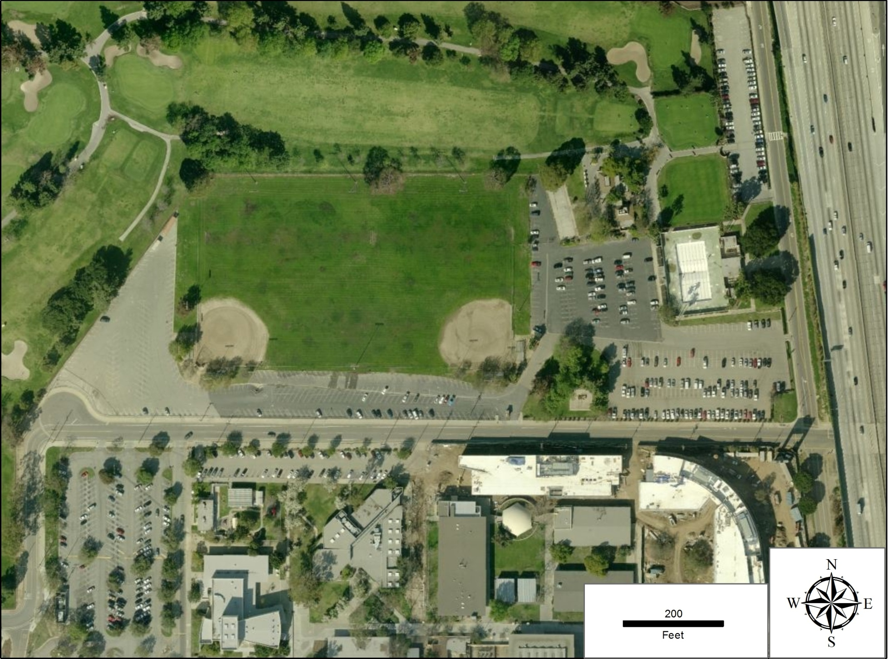

**L Street**

**FIGUEROA PLACE**

**Pedestrian Lane**

SP

TM

Vehicle Flow

Mass Transit Flow

Traffic Management Post

Security Post

**C-POD Staff Bus Drop Off & Pick Up**

**C-POD Staff Parking**

SP

SP

SP

SP

TM

TM

TM

TM

TM

TM

TM

TM

TM

SP

**Vehicle Lane**

**Attachment F: CLOSE UP diagram OF SUPPLY LINE, LOADING LINE & VEHICLE LINE**

**This serves as an example. Update with INFORMATION BASED ON ACTUAL SITE.**

**Pedestrian  
Lane**

**Truck Dark Blue.tifforklift.tifforklift.tifTruck Dark Blue.tifTruck Dark Blue.tif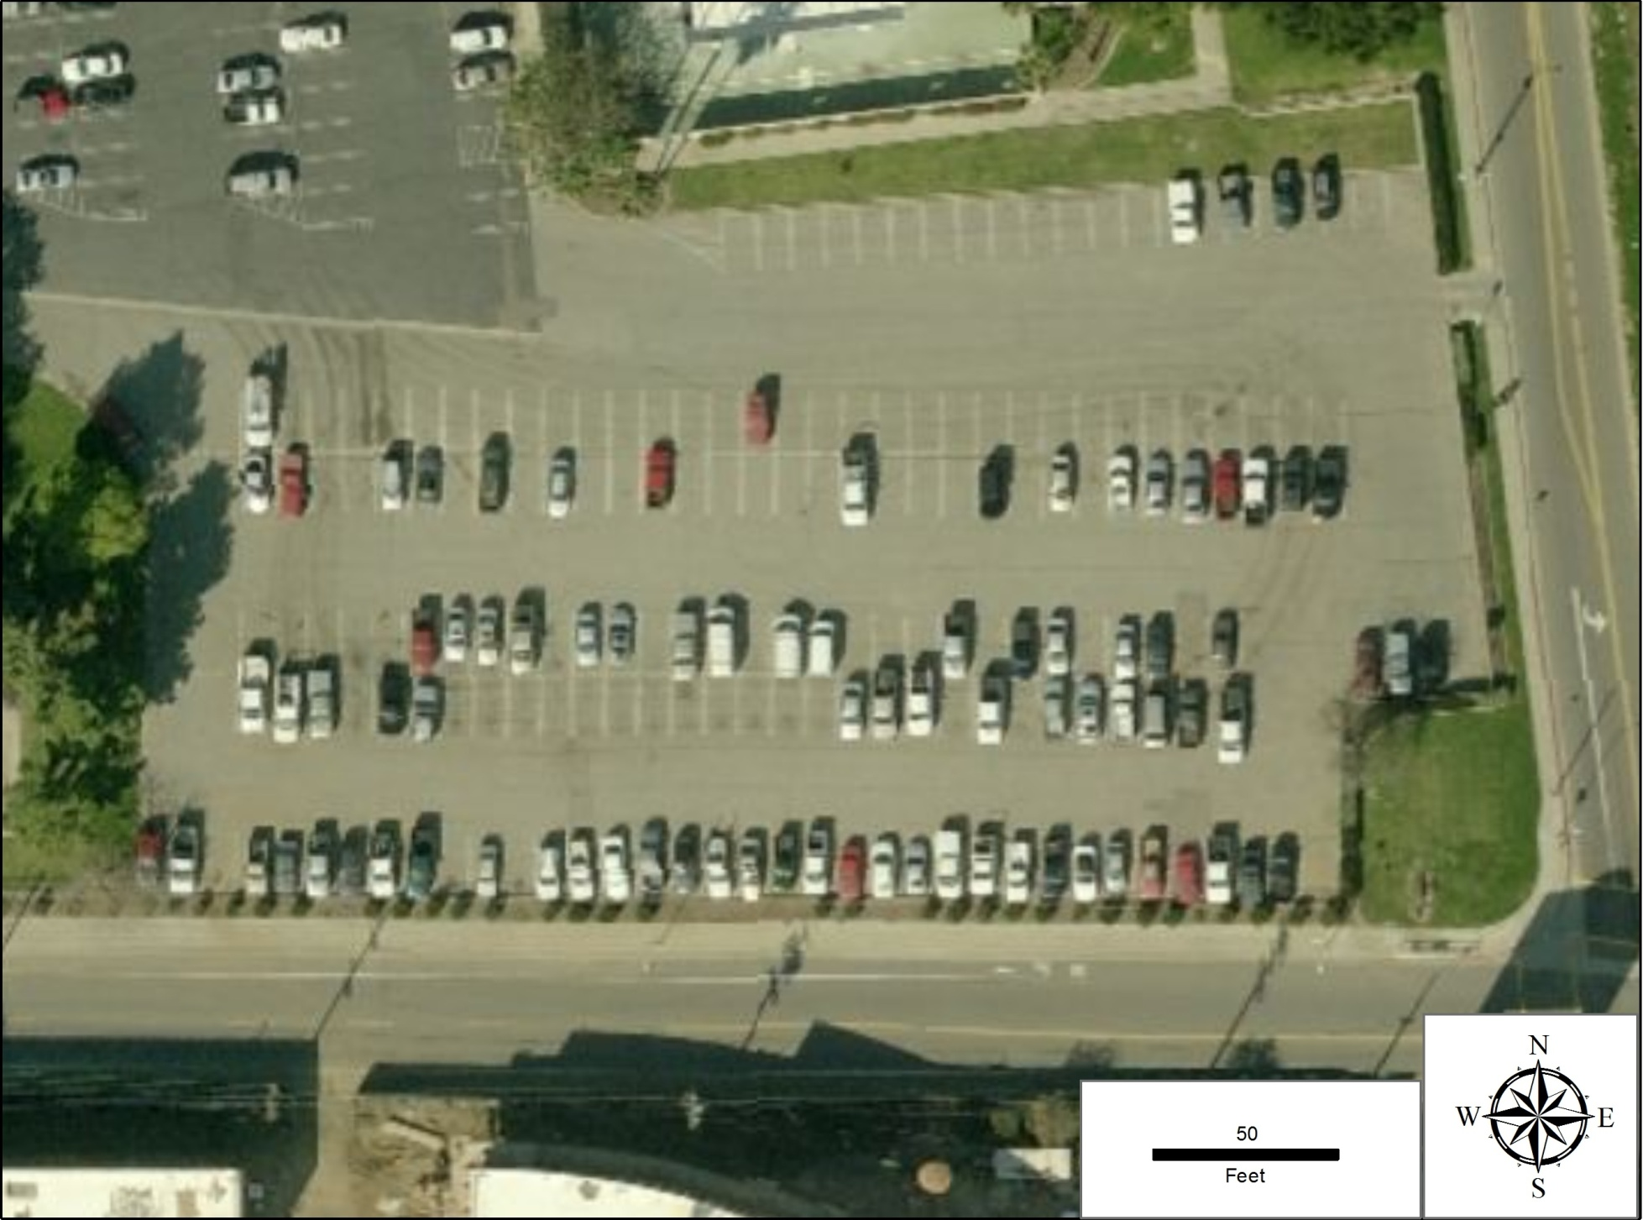**forklift.tifTruck Dark Blue.tifforklift.tifTruck Dark Blue.tifTruck Dark Blue.tifforklift.tif**Attachment G: CLOSE UP diagram OF pedestrian LANE**

**Staff Rest Tent & Restrooms**

Supply Truck Unloading Area

**FIGUEROA PLACE**

**L Street**

**15’**

Supply Line

Loading Point

TM

Loading Line

TM

**50’**

**15’**

SP

**15’**

**20’**

**45’**

**20’**

**150’**

**Dumpster**

TM

Supply & Loading Lines Portable Lighting

Forklift

Traffic Management Post Mass Transit Buses

Security Post Client Vehicles Supply Trucks Mass Transit/Pedestrian Clients

Cones & Barricades

SP

TM

**Mass Transit Pick Up**

TM

TM

SP

SP

**325’**

**156’**

***= Client Vehicles =Supply Trucks***

***= Cones  = Staff Rest Tent***

***= Barricades  = Portable Lighting***

***=Dumpster =Toilets***

***=Security Posts  =Traffic Posts***

***= Fork Lift = Mass Transit***

***= Vehicle Traffic Flow Traffic Flow***

**Loading Point**

**108’**

**20’**

**Space**

**20’**

**Space**

**160’**

**65’**

**325’**

**This serves as an example. Update with INFORMATION BASED ON ACTUAL SITE.**

**forklift.tifforklift.tif**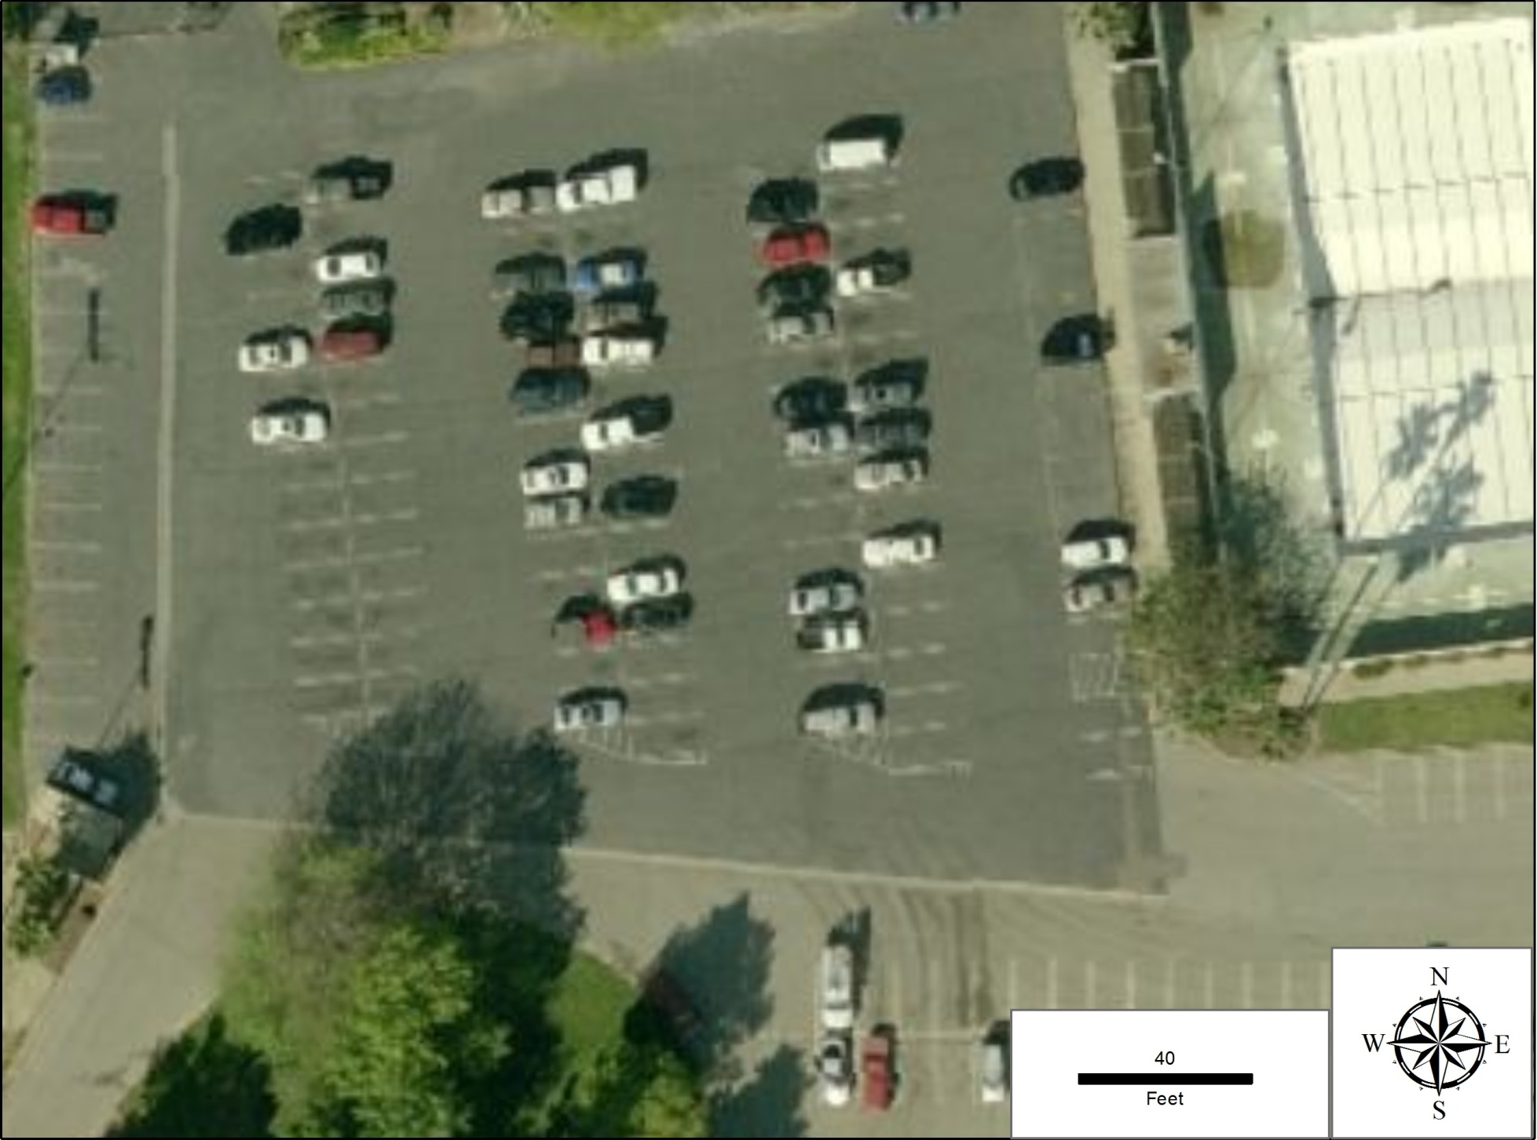

**75’**

**15’**

**15’**

SP

TM

SP

TM

Supply & Loading Lines Forklift

Traffic Management Post Mass Transit Buses

Security Post Client Vehicle Mass Transit/Pedestrian Clients

Cones & Barricades

**Mass Transit Drop Off**

**150’**

**20’**

**30’**

**Mass Transit Pick Up**

**168’**

**240’**