Wragg Incident Base

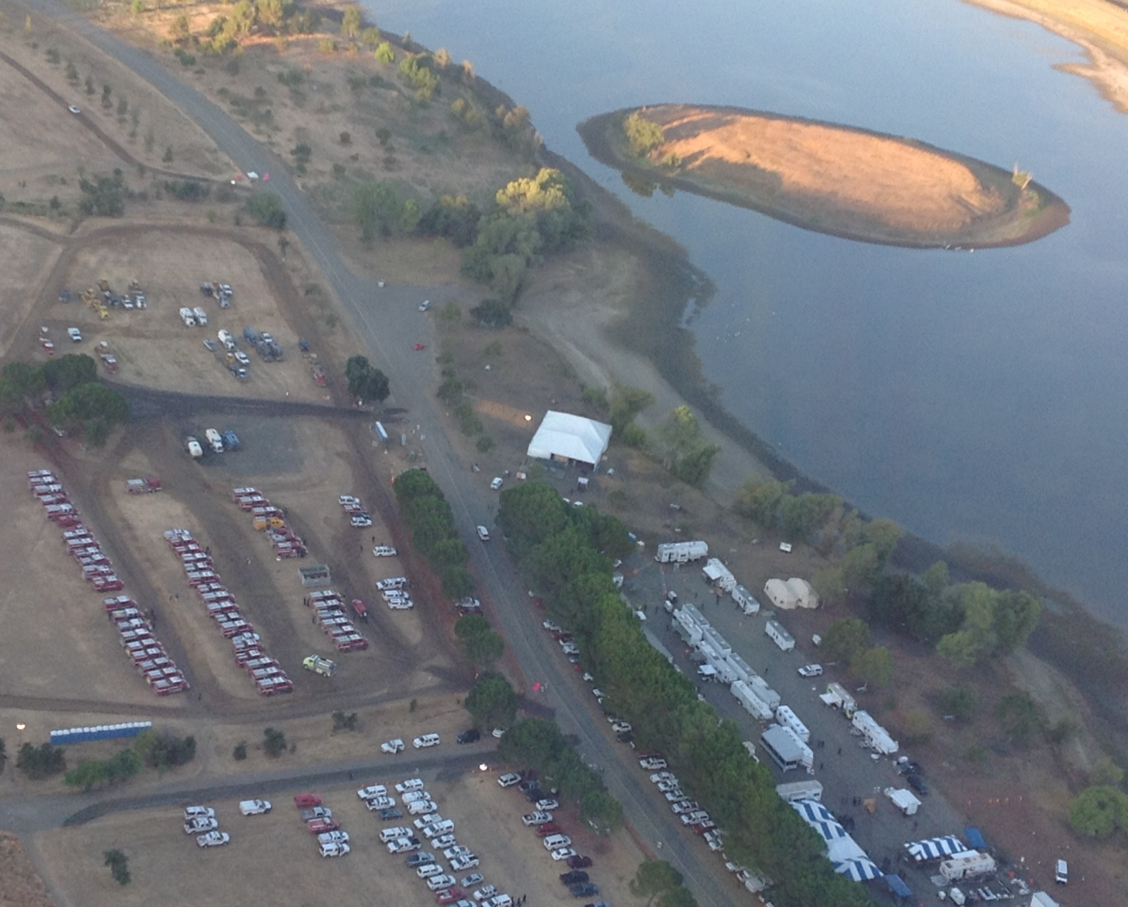

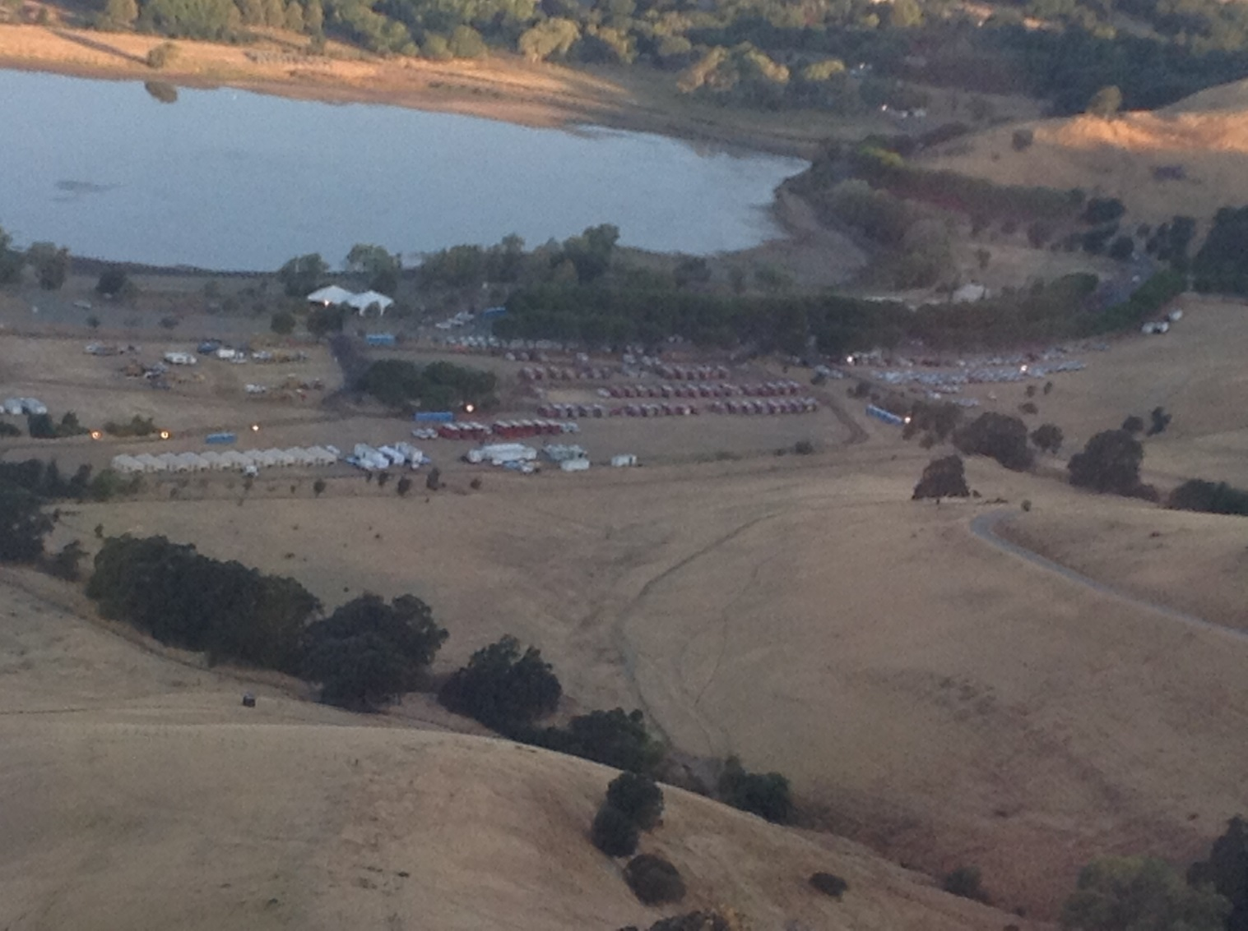

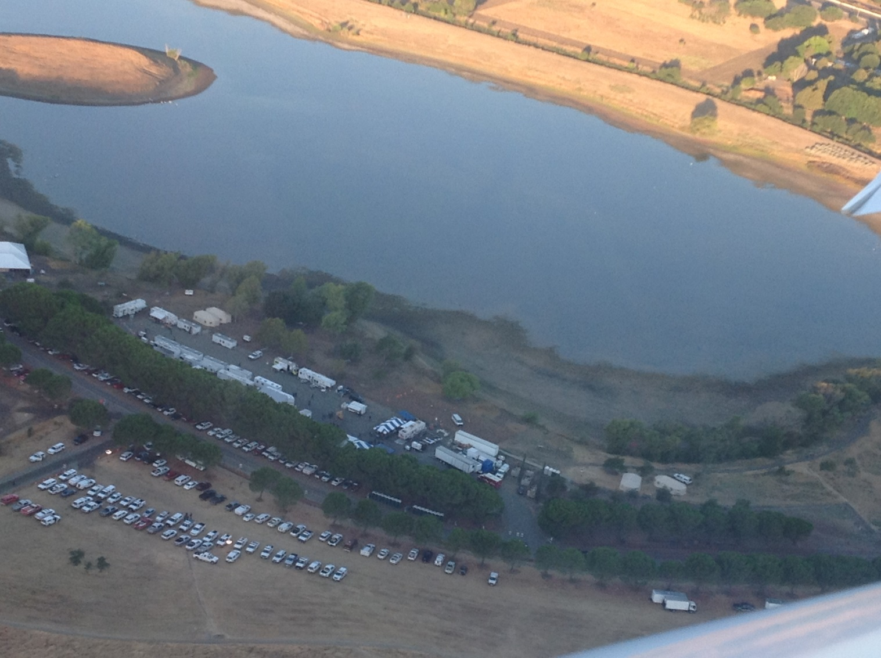

Lunch Vendors

Esposto’s Fine Foods DBA Panini Time
360 Shaw Rd. Suite C
So. San Francisco, CA. 94080
630-589-1886

Whispering Pines Sandwich Co. INC.
1350 Schwab St.
Red Bluff, CA. 96080
Order/Sales Debbie Maxwell 530-200-4810

Perry’s Cozy Diner
590 N. East St.
Woodland, CA. 95776
Jesse Rice 425-319-9216

Blaggs Food Service
Business Address: P.O. Box 1774
Diamond Springs, CA. 95619
530-409-3369
Warehouse Address: 21885 Hwy. 299 E.
Bella Vista, CA. 96008
530-549-5522

Hydration / Ice Vendors
US. Foods
300 Lawrence Drive
Livermore, CA. 94551
Anthony Pelletti
District Sales Mngr.
Cell 707-217-8183
Toll Free 800-682-1228

Sysco Foods Service
5900 Stewart Ave.
Fermont, CA. 94538
1-800-877-7012

Lunch Vendors Cont.

Yolo Ice and Creamery, INC.
1462 Chirchill Downs
Woodland, Ca. 95776
530-662-7337

Mics Vendors

Sheldon Gas Company
One Harbor Center, Suite 310
Suisun, CA. 94585
707-425-2951

Communications Plan
Lagoon Valley ICP

For future incidents located at Lagoon Valley as the ICP, the following plan will assist the incoming communications unit leader in setting up an incident for a Type I incident.

Phones / Fax Lines

As it stands today, AT&T cannot provide any phone or internet lines to support an incident. The Wragg Incident ordered a satellite system to support all phone lines to trailers as well as provide fax lines.

Cell Service

AT&T and Verizon both had strong coverage into Lagoon Valley with 4G LTE. Verizon Crisis Emergency Response Team (VCERT) was used to provide MIFI’s, cell phones, and a cradle point to assist with internet capabilities throughout basecamp. This service was provided to the incident free of charge. In addition, Verizon provided a charging station that was placed by the MKU for crews to charge their phones.

Contact: 1-800-981-9558 for VCERT Services

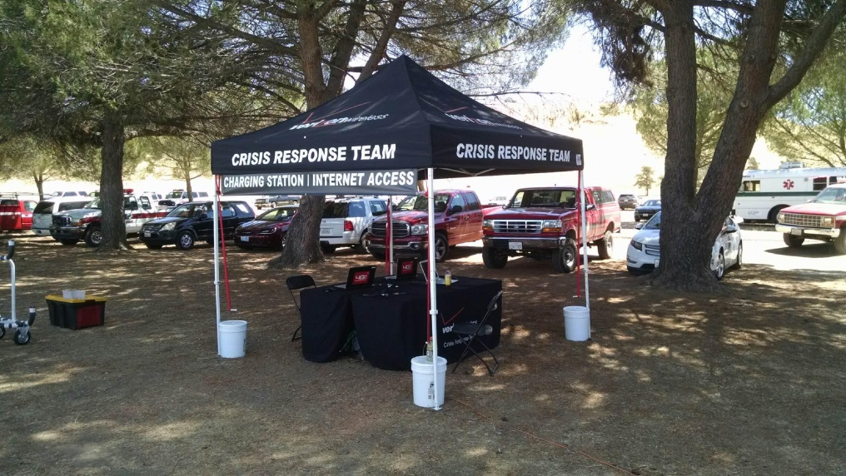
Picture of the Verizon comfort station

Radio Communication Systems

The incident initially started on a Cal Fire Command Net. CDF CMD 2 Tone 13 (Berryessa Peak). This command net provided decent coverage for our incident however the communications into Lagoon Valley could only be accomplished by using a communications unit with an elevated mast system and mobile radio providing 50 Watts for transmission.

During this incident the NIFC radio system was used. Two repeaters were used to provide communications to the incident. The first repeater (NIFC C2) was located at Mt. Vaca and provided strong communications into base camp and allowed the ICP to transmit and receive the command net from a portable radio. The second repeater (NIFC C9) was linked to Wragg Ridge which provided communications coverage to the north part of our incident. Please see the system drawing for a detailed description of the repeater system set up.

The Heli base was located north of the incident across from 13455 Hwy 16, Brooks. Due to their location the Heli base could not communicate on the NIFC repeater system. Due to this issue St. Helena ECC allowed the incident to continue to use CDF CMD 2 Tone 13 for communications between the Heli base and Wragg communications.
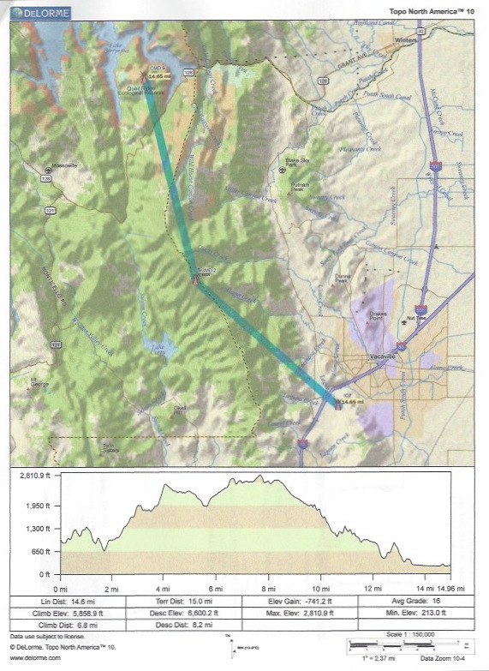
NIFC C9
WRAGG RIDGE

NIFC C2
Mt. VACA

ICP
LAGOON VALLEY

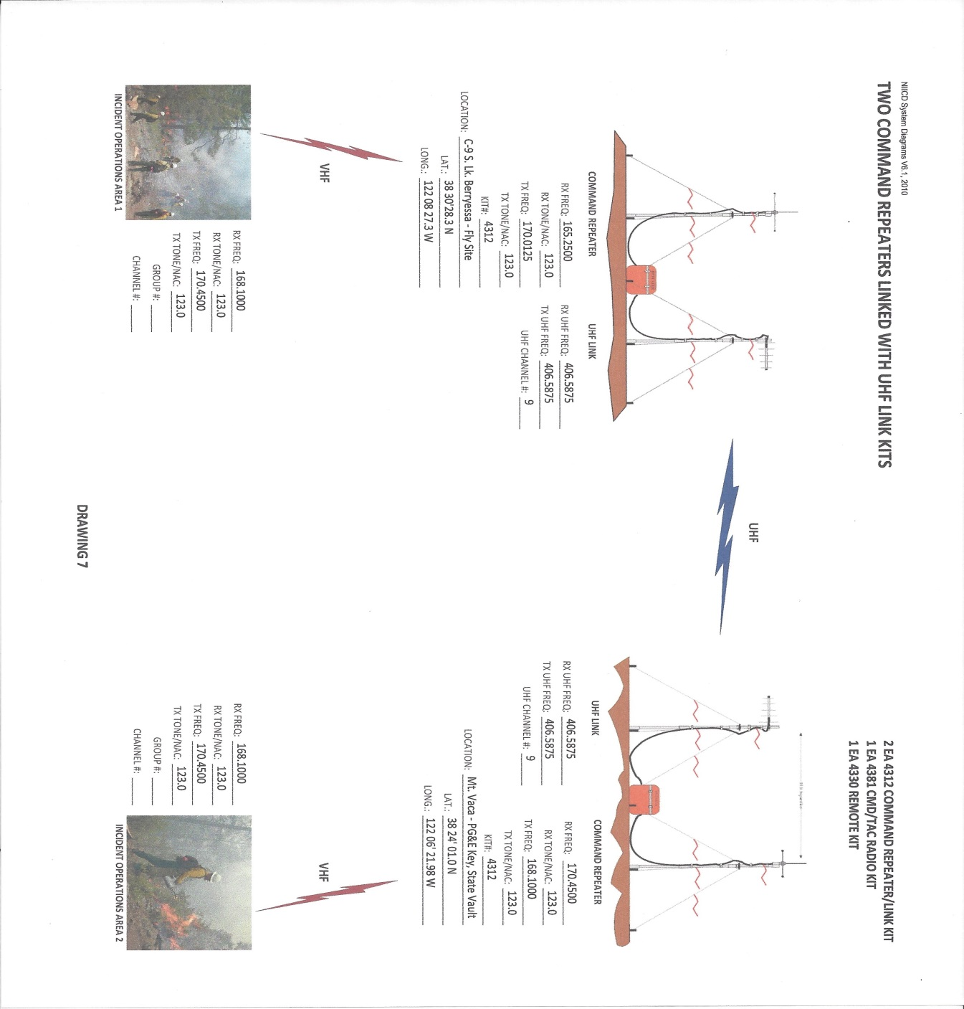
INCIDENT ICP

Motels in the local area were limited; weekends and the middle of the week were the most difficult. We had to venture out to Woodland, Davis, Dixon and Sacramento. We explored the Napa and Benicia area also with no luck. Some hotels in the Napa area would honor the state rate during the week and not the weekends. Overall we found reasonable accommodations for personnel but some had to drive a little further and deal with traffic.
Vacaville Area

Courtyard Marriott- Vacaville: Contact: Melissa or Amber.
120 Nut Tree Pkwy 707-451-9000
This hotel was able to get us a limited number of rooms over the past week but easy to work with.

Fairfield Inn Vacaville: Motel Leader Marriott contact
370 Orange Drive Vacaville 707-469-0800
This hotel was able to get us a limited number of rooms over the past week but easy to work with.

Hampton Inn- Vacaville: Contact Sarah
800 Mason Street Vacaville 707-469-6200
This hotel was able to get us rooms but was limited on certain days of the week, easy to work with.

Holiday Inn Vacaville: Contact Alissa or Ashley
151 Lawrence Dr Vacaville 707-451-3500
We opened this hotel late in the incident, they had no availability during the first half of the incident.

Best Western- Vacaville: Contact: Angela or Lydia.
- Monte Vista Ave Vacaville 707-448-8453
This hotel was able to get us a limited number of rooms over the past week. There is limited parking at this location, not the best for engines. They are currently training new personnel, who are not fully up to date with how their systems run. We stopped using this hotel because of complaints. The atmosphere and people hanging around (living) made people uncomfortable.

Fairfield Area
Hilton Garden Inn Fairfield: Contact Josh
2200 The Courtyard Fairfield 707-426-6900
This hotel had limited availability on certain nights of the weeks, very easy to work with.

Courtyard Marriott- Fairfield: Contact Stephanie
1350 Holiday Lane Fairfield 707-422-4111
This hotel has limited rooms available on certain nights, difficult to work with at first but got a lot better. Will not honor state rate on weekends.

Suisun City
Hampton Inn- Suisun City: Contact: Karen or Kaweah?
2 Harbor Center Dr 707-429-0900
This Hotel very easy to work with; normally has rooms available.

Woodland
Econo Lodge Contact: Daniel
53 W. Main Street Woodland 530-662-9335
Decent place, easy to work with and room availability.

Best Western Shadow Woodland Contact varies by day.
584 N. East Street Woodland 530-666-1251
Didn’t use much, no room availability

Days Inn, Quality Inn, Hampton Inn
Stopped using these hotels, owner manages all 3 hotels. Did not want to honor contract on cancellation times, wants 24 hour notice to cancel. When we did use them they had room availability and no complaints.

Valley Oaks Inn Woodland
Closed this hotel because of health and safety concerns, multiple complaints, would like to remove this hotel from the vendor list.

Davis
Days Inn Davis; contact varies by day.
4100 Chiles Road Davis 530-792-0800
Good room availability, easy to work with.

University Park Davis Contact varies by day.
1111 Richards Blvd Davis 530-756-0910
Good room availability, easy to work with.

Holiday Inn Express & Suits Davis Contact Adam
1640 Research Park Drive 530-297-1500
Opened hotel up late in incident, was easy to set up and work with. Some room availability.

Dixon

Best Western Dixon Contact: CeCe.
1345 Commercial Way Dixon 707-678-1400
Hotel had good availability, easy to work with. This hotel was used mostly for crew FC. Close to Delta camp.

Sacramento
Used multiple hotels in the Sacramento area.

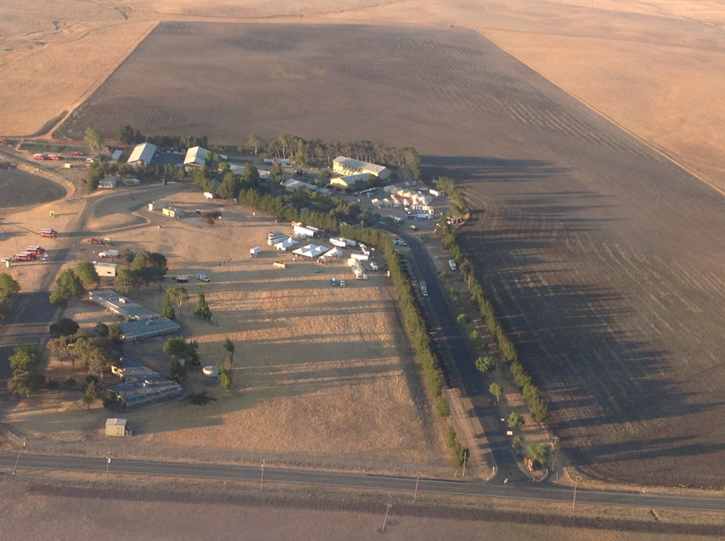

Delta Camp

Delta camp has the ability to mobilize as a base camp with a contracted 26 acre parcel of land. Delta Camp can feed up to 16 S/T of crews in addition to the normal in camp crews before needing a MKU. Delta Camp proved to be beneficial for feeding and housing during the Wragg Incident. At the height of the incident the camp provided feeding for 18 S/T’s.

